**CREATING MICROSERVICES FOR ACCOUNT AND LOAN**

**Account Microservice:**

**AccountController.java**

package com.cognizant.account.controller;  
  
import org.springframework.web.bind.annotation.*;  
  
@RestController  
@RequestMapping("/accounts")  
public class AccountController {  
  
 @GetMapping("/{number}")  
 public Account getAccount(@PathVariable String number) {  
 return new Account(number, "savings", 234343);  
 }  
  
 record Account(String number, String type, double balance) {}  
}

**AccountApplication.java**

package com.cognizant.loan;  
  
import org.springframework.boot.SpringApplication;  
import org.springframework.boot.autoconfigure.SpringBootApplication;  
  
@SpringBootApplication  
public class LoanApplication {  
  
 public static void main(String[] args) {  
 SpringApplication.*run*(LoanApplication.class, args);  
 }  
  
}

**Account running on port 8080**

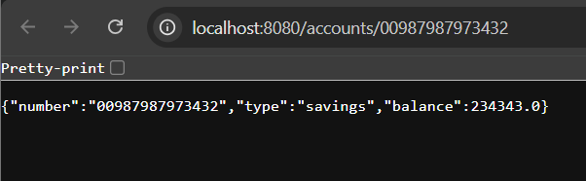

**Loan Microservice:**

**LoanController.java**

package com.cognizant.loan.controller;  
  
import org.springframework.web.bind.annotation.*;  
  
@RestController  
@RequestMapping("/loans")  
public class LoanController {  
  
 @GetMapping("/{number}")  
 public Loan getLoan(@PathVariable String number) {  
 return new Loan(number, "car", 400000, 3258, 18);  
 }  
  
 record Loan(String number, String type, double loan, int emi, int tenure) {}  
}

**LoanApplication.java**

package com.cognizant.loan;  
  
import org.springframework.boot.SpringApplication;  
import org.springframework.boot.autoconfigure.SpringBootApplication;  
  
@SpringBootApplication  
public class LoanApplication {  
  
 public static void main(String[] args) {  
 SpringApplication.*run*(LoanApplication.class, args);  
 }  
  
}

**application.properties**

server.port=8081

**Loan running on port 8081**

